Time: 60 minutes
Directions: Each of the 30 multiple-choice questions is followed by five possible answer choices. Choices A through D will provide answers, while Choice E is for none of the above. Scoring will be as follows: 5 points for a correct answer, 0 for a wrong answer, and 1 for a blank answer (for a maximum possible score of 150). Figures are not necessarily drawn to scale. Do not choose incomplete answers: if a question has more than one solution, do not select a choice that only provides one of the solutions!
Calculators are not permitted.

1. Batman buys 6 bars of chocolate at $1.00 per bar and 3 milkshakes at $2.50 per milkshake. Which equation can be used to find how much he owes?
A) (6 × $2.50) + $2.50 = x B) (6 × $2.50) – (3 × $2.50) = x
C) 9 × $2.50 = x D) (6 × $1.00) + (3 × $2.50) = x E) NOTA

2. As everyone in Gotham City knows, the Joker is a very mean person. Find the mean of the following numbers: 14, 27, 4, 25, 28, 10, and 11.
A) 0 B) 14 C) 17 D) 119 E) NOTA

3. The Joker sent Batman and Robin an evil message in a secret code made up of five mixed numbers. To figure out the message, they must put it into a decoder that only accepts data as improper fractions. Help them out by changing the Joker’s mixed numbers:
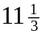, 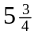, 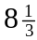, 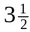, 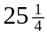
to improper fractions.
A) 11, 5, 8, 3, 25 B) 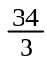, 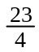, 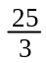, 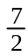, 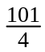 C) 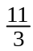, 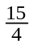, 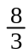, 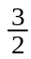, 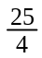 D) 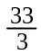,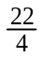,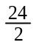,,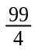 E) NOTA

Use the following information to answer Questions 4 and 5. Batman and Robin are having a rare argument. Robin baked a cake and then cut pieces for himself and Batman. But Batman thinks Robin’s piece is bigger than his own. Robin says the pieces are equal. They have agreed to accept your answer as the solution to the argument. This means that Batman and Robin’s friendship depends on your correct answers to questions 4 and 5:

4. If Robin’s piece is 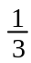 of the whole cake and Batman’s piece is 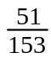 of the whole cake, then fill in the blank:
Robin’s piece ________ Batman’s piece
A) 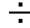 B) > C) < D) = E) NOTA

5. What fraction of Robin’s original cake is left over after Batman and Robin have eaten their own pieces and gone to bed?
A) 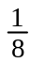 B) 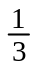 C) 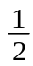 D) 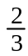 E) NOTA

6. If the dotted line in the figure below is the axis of symmetry, help Batman find the perimeter of the total figure.
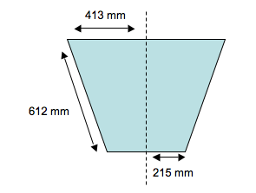
A) 1,150 mm B) 1,240 mm C) 1,845 mm D) 2,480 mm E) NOTA

7. Batman has 4 water balloons and the Joker is within throwing distance, but each balloon is filled with a different amount of water. The first balloon is full of water, the second is 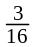 full, the third is full, and the fourth is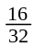 full. Batman only has one chance to hit the Joker with the greatest amount of water. Which balloon should Batman throw?
A) first B) second C) third D) fourth E) NOTA

8. The floor of the Batcave is shaped like an octagon (it has eight sides). If the length of each side is 112 feet, find the total perimeter of the Batcave’s floor. Then divide that number by 4, multiply by 3, subtract 2, and add 1. What is the answer?
A) 671 B) 709 C) 756 D) 800 E) NOTA

9. Batman is a member of the Justice League of America, a group of superheroes who kill bad guys. Below is a line plot showing the number of bad guys killed by each Justice League member in 2006.
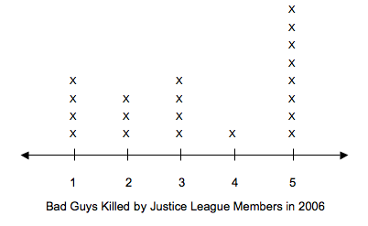
What is the median number of bad guys killed by Justice League members in 2006?
A) 2 B) 3 C) 4 D) 5 E) NOTA

10. Speaking of the Justice League, Batman has a Justice League meeting to go to tomorrow at 11:00 AM. He snoozes for 5 minutes after his alarms rings, takes 20 minutes to read the newspaper, 15 minutes to shower, 35 minutes to get dressed, 20 minutes to eat breakfast, and 10 minutes to drive to the meeting in the Batmobile. What time should he set his alarm for?
A) 9:05 AM B) 9:10 AM C) 9:15 AM D) 9:20 AM E) NOTA

11. If the Batmobile can drive 36 miles using 1 gallon of gas and there are 5,280 feet in a mile, how many feet can the Batmobile drive using 2 gallons of gas?
A) 215, 620 B) 299, 810 C) 314, 159 D) 380,160 E) NOTA

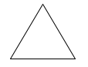
12. Batman showed Robin the four triangles below and asked him to pick the one that is both obtuse and scalene. Robin got the question right. Which triangle did he choose?

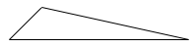
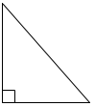
A) B)

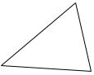
C) D)

E) NOTA

13. Batman and Batwoman are going out to lunch at their favorite deli. The menu lists 8 sandwiches and 4 drinks. How many different lunch choices are there if the lunch special includes one sandwich and one drink?
A) 8 B) 12 C) 16 D) 32 E) NOTA

14. Batman wants to build a shelf for his Bat-library. He has 10 books to put on the shelf. They are very big books: 2, 2.5, 3, 4.5, 5, 5.5, 7, 7.5, 8, and 9 inches thick! If he wants to leave 3 inches on each side of the books for knick-knacks, how many feet long should his shelf be?
A) 5 feet B) 5 feet, 3 inches C) 5 feet, 11 inches D) 6 feet
E) NOTA

15. Robin is at the grocery store buying food. He buys bread for $3.99, chocolate milk for $2.15, a box of granola bars for $4.50, and a jar of pickles for $1.29. He gives the cashier two $10 bills. How much change should he receive?
A) $4.50 B) $6.13 C) $7.28 D) $8.07 E) NOTA

16. The Joker promised Batman that if Batman could solve the problem below, the Joker would stop doing evil in Gotham City for 48 hours. But Batman needs help! Solve the Joker’s problem if A = 82.
3 (90 - A) + 18 =
A) 20 B) 42 C) 78 D) 204 E) NOTA

17. Gotham City, Batman’s hometown, has a population of 3 million people. On a certain night, three thousand four hundred and twenty of those people are robbers on the loose. If 9 Justice League members are on patrol that night, how many robbers does each Justice League member need to catch for all the robbers to be stopped?
A) 280 B) 430 C) 380 D) 3800 E) NOTA

18. Below is a grid map of Gotham City. Batman was alerted of crimes occurring at points S, H, P, J, and V. Give him the ordered pairs that correspond to these letters.

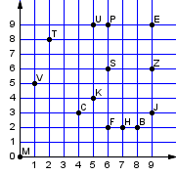

A) (6,6), (7,2), (6,9), (9,3), (1,5) B) (6,6), (7,1), (5,9), (9,4), (0,5)
C) (6,6), (8,1), (7,3), (9,0), (3,5) D) (6,2), (7,3), (8,2), (2,8), (9,6)
E) NOTA

19. What are the next three numbers in the sequence below?
25, 39, 53, ___, ___, ___

A) 67, 81, 95 B) 69, 77, 91 C) 59, 66, 71 D) 82, 105, 121 E) NOTA

20. Batman, Robin, the Joker, and Harley (the Joker’s sidekick) were born in the months of January, April, August, and November of the same year. If Batman is older than Harley, Harley is older than Robin, Robin is younger than Batman and the Joker is older than Batman, list the people from oldest to youngest.
A) Joker, Harley, Robin, Batman B) Batman, Robin, Joker, Harley
C) Joker, Batman, Harley, Robin D) Batman, Joker, Harley, Robin E) NOTA

21. Batman has found the Joker’s secret hideout, but needs a three-number code to get inside. He learns that the answer to each of the expressions below represents one of the numbers in the code.
64 n + 20 (if n = 8)
14 x 12 n (if n = 2)
n + (27 ÷ 9) (if n = 58)
What is the code?
A) 13 – 77 – 61 B) 28 – 84 – 61 C) 31 – 77 – 23
D) 90 – 84 – 72 E) NOTA

22. The “Dynamic Duo”, Batman and Robin, are playing a game with the spinner below. What is the probability that one of them will spin a 3?
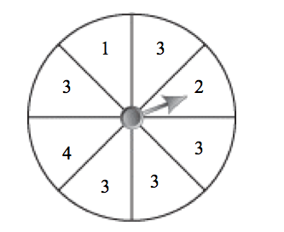
A)
B)
C) 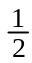
D) 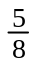
E) NOTA

23. Robin bought some bubblegum for $0.58. He was given $0.42 in change. What is the least number of coins he could have received?
A) 4 B) 5 C) 6 D) 7 E) NOTA

24. Everyone knows that Batman and Robin have known each other for a long time. But exactly how many years have they been best friends? To answer, solve the equation below if B = 3 and R = 2.
8 x B + (R – 1) x 5 (B + R) – (6 + R 2) =
A) 11 B) 13 C) 16 D) 18 E) NOTA

25. What is the perimeter of the figure below?
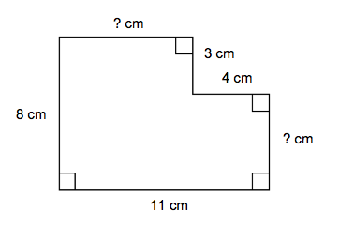
A) 26 cm B) 36 cm C) 38 cm D) 41 cm E) NOTA

26. Robin has 2 dollars and 1 quarter. He wants to exchange his money with Joker for nickels. How many nickels should Joker give Robin for his 2 dollars and 1 quarter?
A) 25 B) 30 C) 35 D) 40 E) NOTA

27. Robin took a measurement of Batman’s height. Batman’s height is 1.8288 meters. Round that number the nearest tenths place. Then multiply it by 3 and divide by 2.
A) 1.8 B) 1.92 C) 2.4 D) 2.7 E) NOTA

28. Batman is having a small party and needs to know how many people are coming. Robin knows, but will only tell Batman that the number of people coming is two times the Greatest Common Factor of 50 and 35. If every guest receives a party favor, how many party favors should Batman buy for his guests?
A) 5 B) 10 C) 15 D) 20 E) NOTA

29. Robin’s pet fish lives in a rectangular glass aquarium. Robin wants to place some rocks on the bottom of the aquarium. The bottom of the aquarium is 7.5 cm wide and 14.25 cm long. What is the area of the surface Robin wants to cover with rocks, rounded to the nearest tenths place?
A) 101.7 cm B) 103.2 cm C) 106.9 cm D) 109.1 cm E) NOTA

30. Batman and Robin like to take long bike rides on Saturday afternoons. If one wheel on Batman’s bike turns 635 times per mile, how many times will it turn if he bikes 26 miles?
A) 5,080 B) 9,245 C) 12,500 D) 16,510 E) NOTA

CHILES MINI MU COMPETITION
ELEMENTARY – BATMAN: THE STORY CONTINUES
ANSWERS

- D
- C
- B
- D
- B
- D
- A
- A
- B
- C
- D
- B
- D
- A
- D

- B
- C
- A
- A
- C
- B
- D
- B
- D
- C
- E
- D
- B
- C
- D

SOLUTIONS

- 6 bars at $1.00 each plus 3 milkshakes at $2.50 each equals the total cost.
- The sum of all the numbers is 119. 119/7 equals 17.
- B is a list of the numbers changed to improper fractions.
- 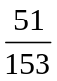 is equivalent to , so the pieces are equal.
- The whole cake minus the 2/3 that Batman and Robin ate is 1/3 left over.
- The axis of symmetry runs through the midpoint of the two bases, so the length of the top base is 826 and the length of the bottom base is 430. The sides of a trapezoid are equal in length, so each side is 612. 826 + 430 + 612 + 612 = 2,480
- 3/4 is the largest fraction in the problem, so that balloon is fullest.
- 8(112) = 896. 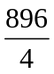 = 224. 2243 = 672. 672-2 = 670. 670 + 1 = 671.
- The median is 3.
- In total, it takes Batman 105 minutes to get from his bed to the meeting. 105 minutes = 1 hour, 45 minutes. 11:00 – 1 hour, 45 minutes = 9:15.
- Batman can drive 72 miles on 2 gallons of gas. 72 miles 5,280 feet per mile = 380,160.
- B is the only triangle that is obtuse.
- Number of choices = 84 = 32.
- The books alone take up 54 inches of space + 6 inches = 60 inches. 60/12 = 5.
- 3.99 + 2.15 + 4.50 + 1.29 = 11.93; 20.00 – 11.93 = 8.07
- 3(90-82) + 18. 3*8 is 24. 24 + 18 = 42.
- 3,420 / 9 = 380 robbers each.
- These are the ordered pairs that correspond to the letters listed.
- The pattern is “add 14”. 53 + 14 = 67. 67 + 14 = 81. 81 + 14 = 95.
- Batman and Harley are older than Robin, and the Joker is older than Batman. Therefore Robin is the youngest. Batman is older than Harley, so Harley is the second youngest. The Joker is older than Batman.
- 64/8 + 20 = 28. 14*12/2 = 84. 58 + (27/9) = 61.
- Five of the spaces on the spinner are labeled “3”. There are 8 spaces in all.
- He received a quarter, a dime, a nickel, and two pennies.
- 8*3 + (2-1) *5/(3+2) – (6 + 2/2) = 8*3 + (1) *5/(5) – (7) = 24 + 1 – 7 = 18.
- The unknown sides are 7 and 5. 8 + 11 + 5 + 4 + 3 + 7 = 38.
- He should receive 45 nickels for $2.25.
- 1.8288 rounded to the tens place is 1.8; 3(1.8) = 5.4; 5.4/2 = 2.7
- The factors of 35 are 1, 5, 7, and 35. The only one that divides evenly into 50 is 5, so it is the GCF. 2*5 = 10.
- (14.25)*(7.5) = 106.8750; rounding this gives 106.9.
- 635 turns per mile * 26 miles = 16,510 turns.

